

Static Website with Amazon S3

Amazon S3 provides world-class security, scalability, and and performance, making it the ideal choice for hosting your website. With our guide, you'll learn everything you need to know to get started, from setting up your S3 bucket to configuring bucket permissions and policies.

We'll also show you how to upload your website files to S3



Introduction to Static Website

A static website is a collection of web pages that are delivered to the user exactly as they are stored. Unlike dynamic websites, static websites do not contain server-side processing or database integration. This makes them ideal for hosting on Amazon S3, which excels at securely and efficiently delivering static content to users across the globe.

Static websites are typically built using HTML, CSS, and JavaScript files that can be stored easily on Amazon S3, and delivered using Amazon CloudFront. By combining these services, you can enjoy global content delivery at high speeds. Additionally, the simple architecture of static sites makes them less vulnerable to cyberattacks.



What is AWS?

200+

Services for computing, storage, networking, and more

Popular programming languages

Java, Python, Json toolkits for easy integration

Robust security features

Compliance certifications for data privacy and protection



Know More about S3

What is S3?

Amazon S3 is a scalable, highly available, and durable cloud storage service that can be used to store and retrieve any amount of data from anywhere on the web.

Benefits of S3

Fast, reliable, and secure storage that offers easy management, automatic backups, versioning, encryption, and global accessibility at low costs, with a pay-as-you-go

model.

Use Cases

S3 can be used for website hosting, media sharing, backup and archiving, data ingestion, machine learning, analytics, IoT, and more.

Setting up an S3 Bucket for Website Hosting

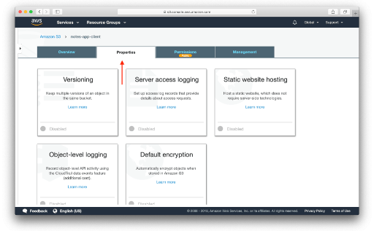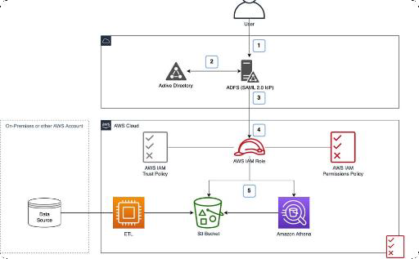

# Create a Bucket

Go to the S3 console and create a new bucket. Choose a unique name, select the region closest

to your visitors, and set up

# Configure Properties

Configure the bucket properties to enable website hosting, set the default error and index

documents, and enable

# Create a Policy

Create a bucket policy that allows anonymous access to the files in the bucket, while

restricting access to the bucket

#### Create an S3 Bucket

1. **Open the S3 Console**: Go to the S3 console in the AWS Management Console.
2. **Create a Bucket**:
   * Click on “Create bucket”.
   * Enter a unique bucket name (e.g., my-static-website).
   * Choose the region closest to you.
   * Click "Create bucket" at the bottom of the page.

#### Step 3: Configure the Bucket for Static Website Hosting

1. **Open Your Bucket**: Click on the bucket you just created.
2. **Enable Static Website Hosting**:
   * Go to the "Properties" tab.
   * Scroll down to "Static website hosting".
   * Select “Use this bucket to host a website”.
   * For "Index document", enter index.html.
   * Optionally, for "Error document", enter error.html.
   * Click "Save".

#### Step 4: Upload Your Website Files

1. **Upload Files**:
   * Go to the "Objects" tab.
   * Click on “Upload”.
   * Add your index.html, styles.css, scripts.js, and any other files.
   * Click “Upload” to start the upload process.

#### Step 5: Set Bucket Permissions

1. **Set Bucket Policy**:
   * Go to the "Permissions" tab.
   * Scroll down to "Bucket policy".
   * Add the following bucket policy to make the contents publicly accessible: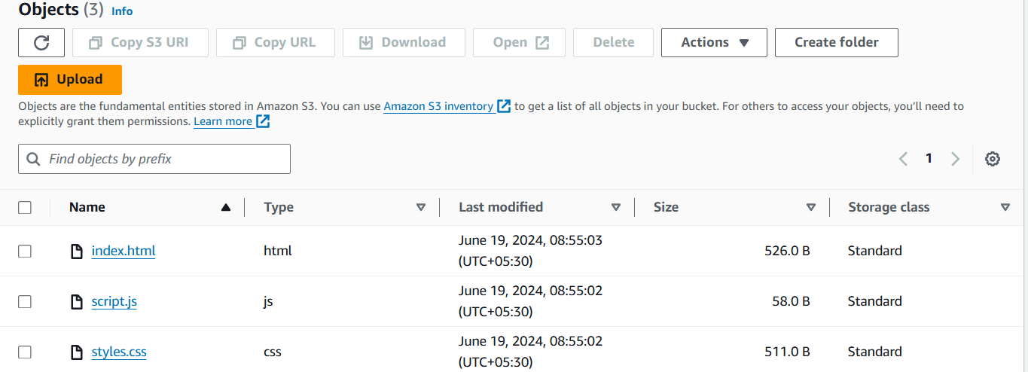

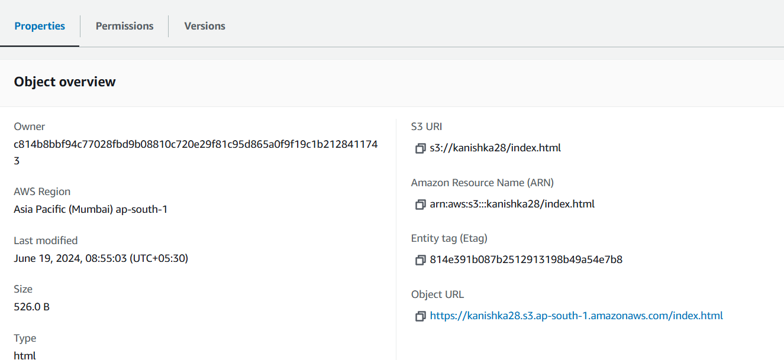Configuring Bucket Permissions and Policies

# Access Control List (ACL)

1

Use ACL to grant permissions to individual users, groups, or predefined Amazon S3 groups. ACL defines the operations that are allowed or denied on the objects in the bucket.

# Bucket Policy

Use Bucket Policy to grant permissions to anyone who has access to the Internet.

2

Bucket Policy defines the operations that are allowed or denied on the bucket or its contents.

Uploading Files to S3



# Permissions

Ensure that the files are uploaded with

permissions that allow public acces.

# File Types

Upload your website file to S3 bucket according to their file type. This may include HTML,CSS,JavaScript,images, and other assets.

1

2

3

# Web Hosting

Set website hosting option such as the index document and error document in the Properties tab of your S3 bucket.

Enabling Static Website Hosting on S3

Access the Website URL

After enabling Static Website Hosting on S3, access your website via the URL provided in the "Static website hosting" tab of your bucket's Properties page. You can share this URL with others for public access to the website.

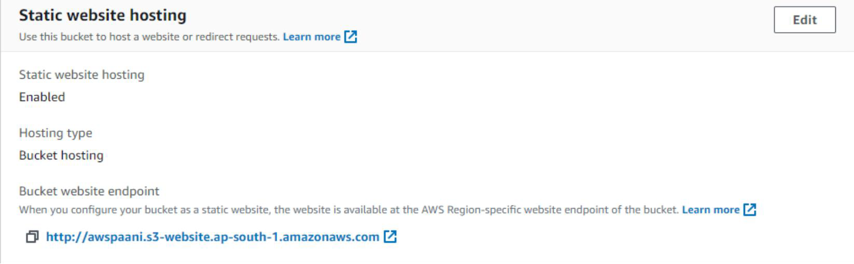



# Conclusion

Deploying a static website on AWS is a cost-effective, scalable, and reliable solution for hosting web content. By utilizing Amazon S3, you can easily store and serve static files such as HTML, CSS, and JavaScript. Enhancements such as AWS CloudFront and Route 53 further improve the performance and security of your website, while also providing options for custom domain management.